Automate the Boring Stuff

Programming Basics

* Continue to go to next iteration of the loop
* Installing packages

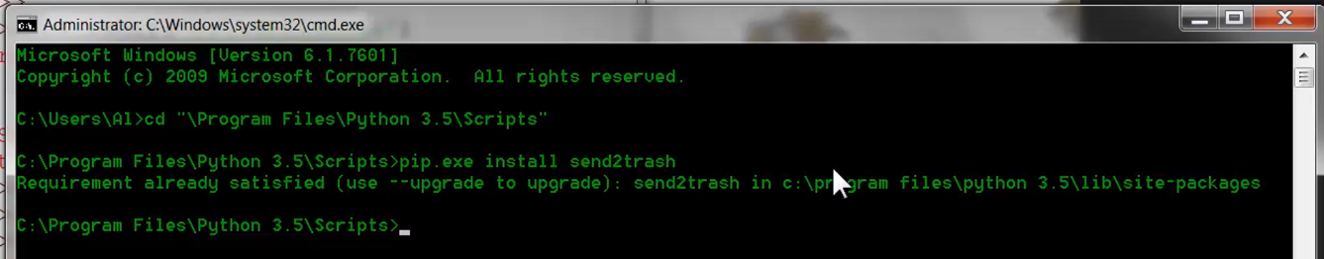

Regular Expressions

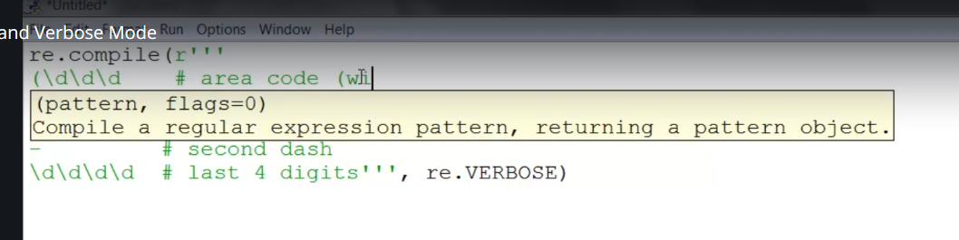

* Verbose allows us to add the spaces and comments to make long re more understandable
* Can pipe multiple arguments for 2nd “argument” if necessary

OS

* OS package is very useful for working with files and file paths

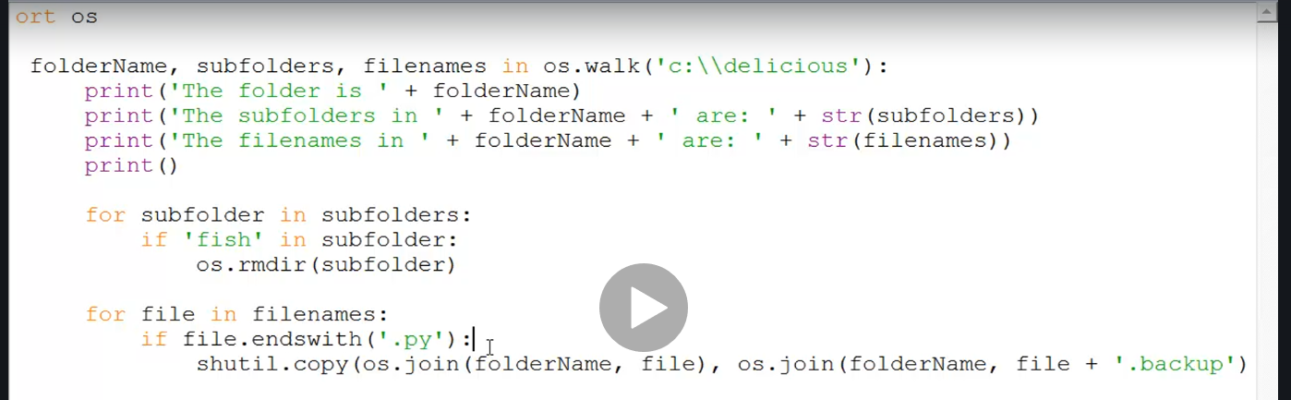

SHUTIL

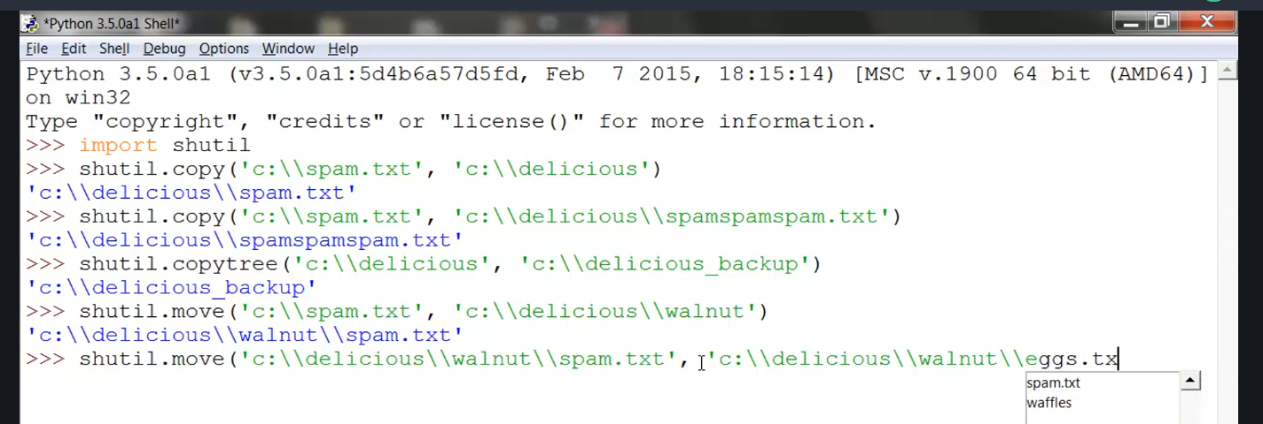

* Useful for moving files around

Traceback

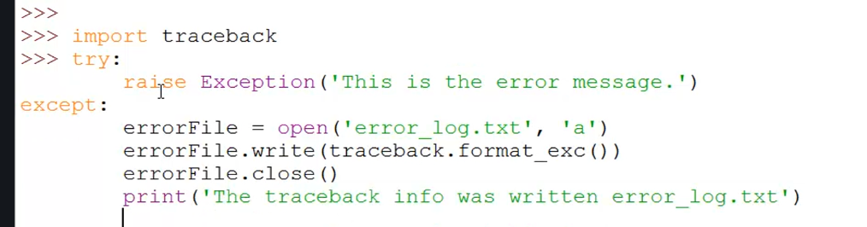

* Write to an error log; raises an error, but program can continue …
* Assertions are for detection programmer errors; user errors should raise exceptions

Logging

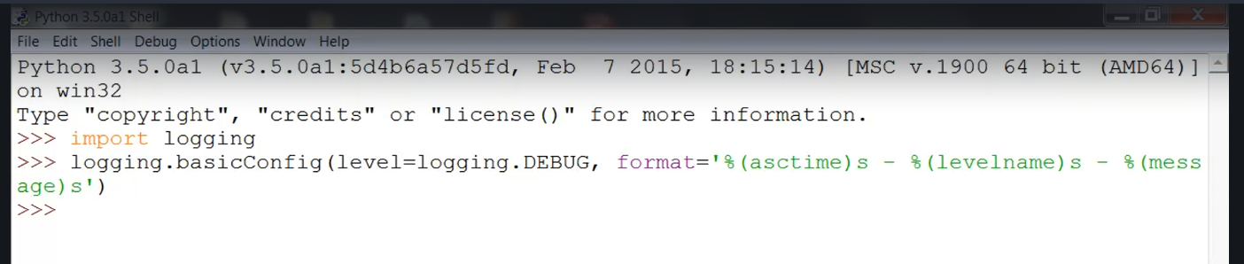

Controlling Web Browser

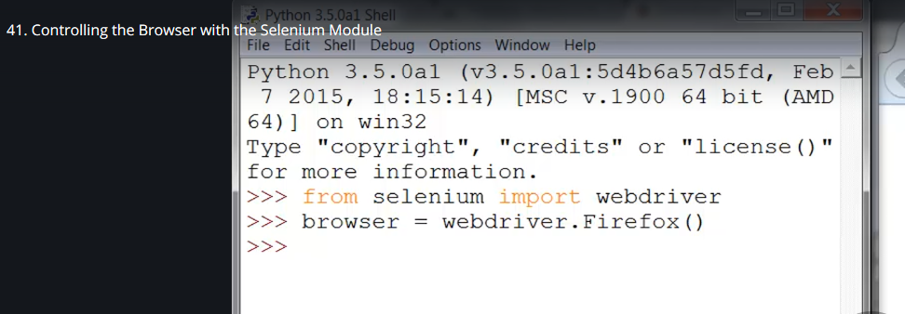

Reading and Editing PDFs

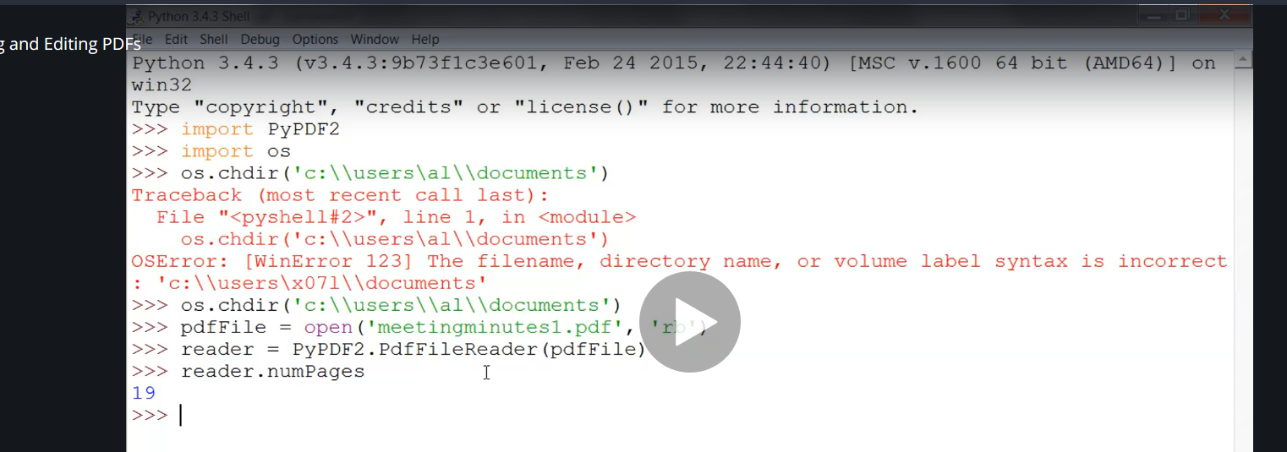

* There are many different PDF modules, but PyPDF2 is the best at reading text, can’t currently read images
* The formatting can be difficult to get the exact text

Email with Python

* Logging into email server

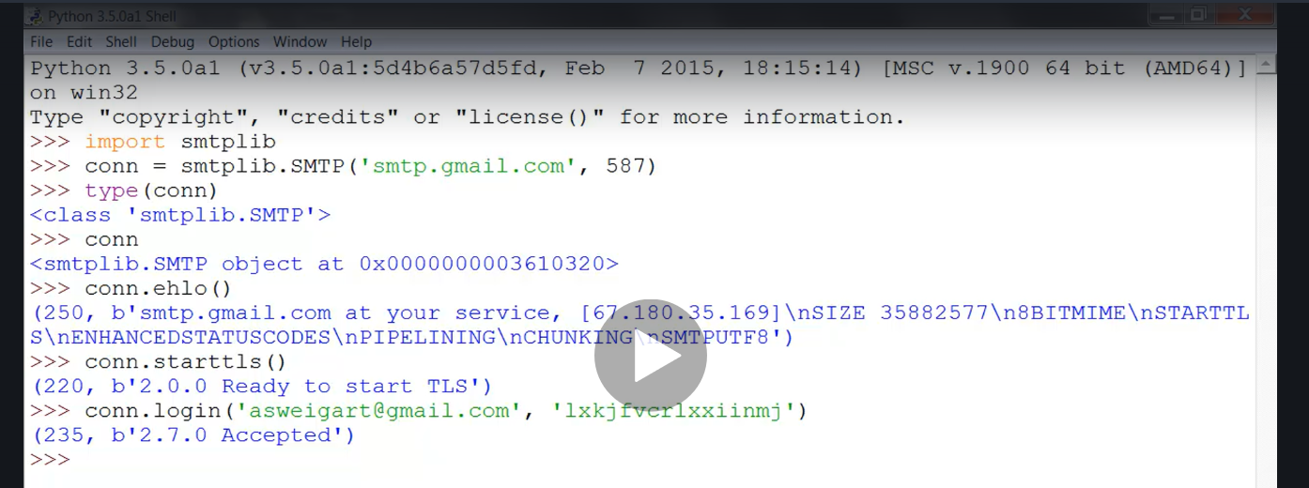

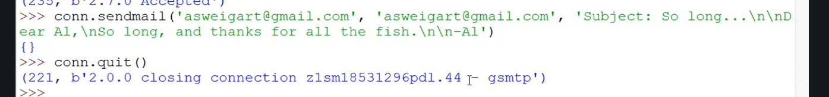

* Sending mail
* Searching Inbox

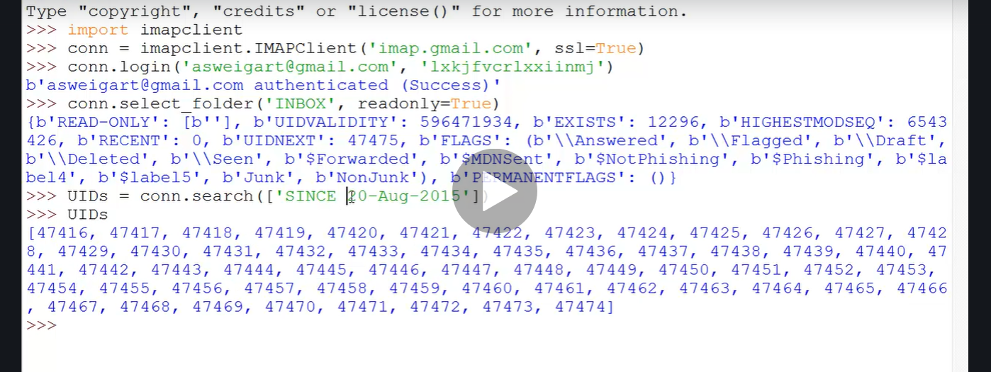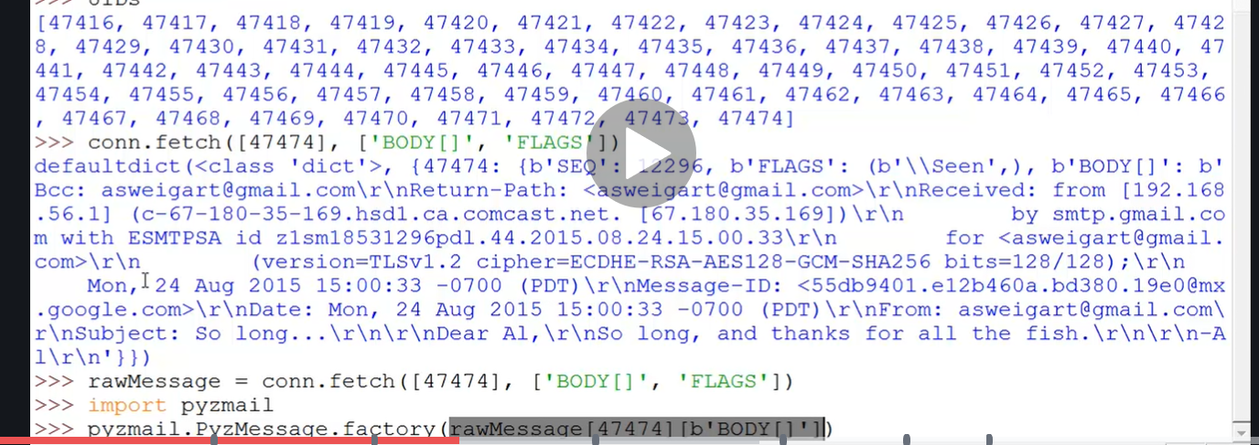

pyautogui

* Because JDE is all keystroke based, maybe there is another task you can automate?
* Moving the mouse

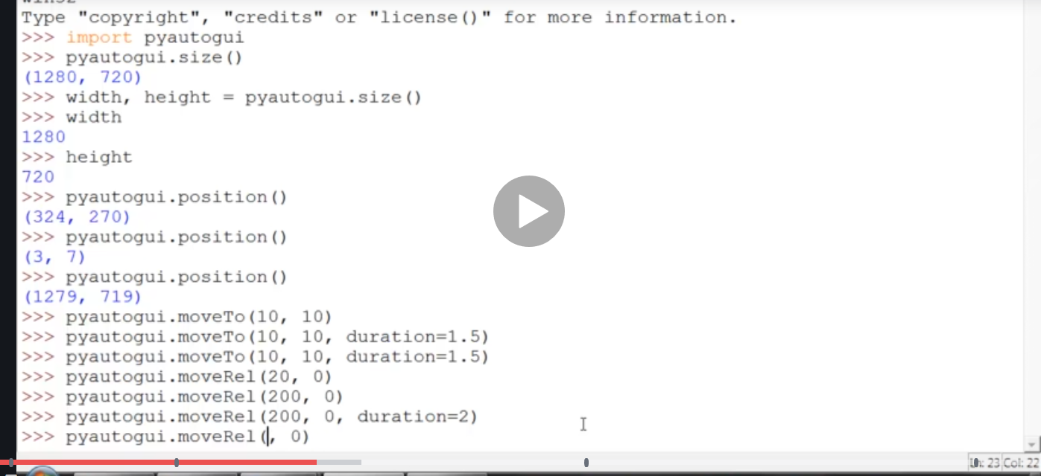

* Use this function to record locations on your screen

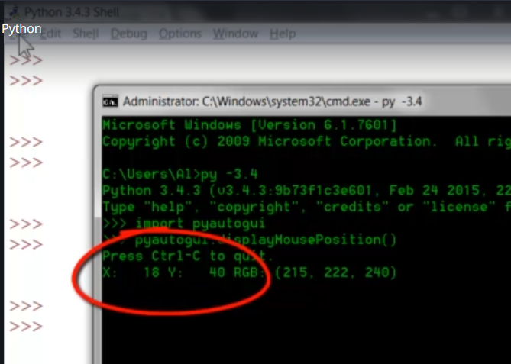

* Keys on the keyboard (not typing a string)

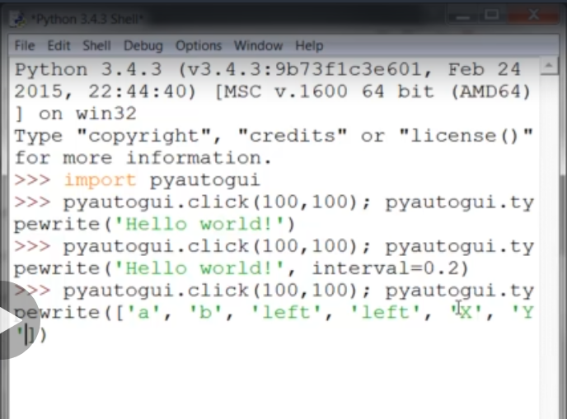

* Image recognition offers huge potential for opportunity

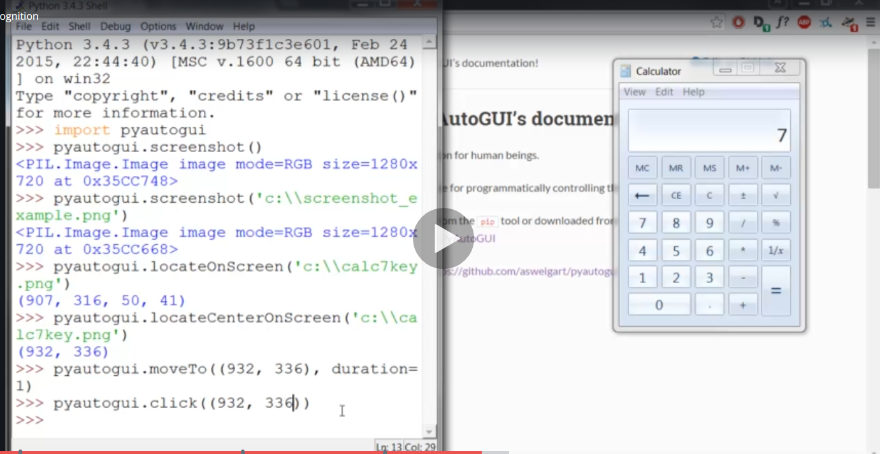

* Computationally expensive and must be pixel perfect
* Look for ways to speed up and do partial matches!